Performance and Optimization:

Criteria: In High speed trading system, the performance is usually measured in latency

Performance Metrics: is the latency of the system

So the performance metric here would be the latency measured in units of time.

The video player delivers video content to the user screen. In this case, delivering all the frames as fine possible would actually be terrible. For example, movies are recorded 30 frames per second, and we show it a thousand frames per second. Then the user will not actually see anything.

So what we actually want is to show the content to the user at the correct and

precise frame rate with minimal jitter. So the performance metric here would be the precision and the accuracy of the frame rate.

Another.

In last example, it can be an application that performs machine

learning on a large volume of data. And it has to give a recommendation based on that data every 24 hours. In this case, the more data the system can ingest in this 24 hours to give us

a better prediction, the better for us. So the performance metric here is the throughput.

And the latency or the lack of jitter is actually not that important.

The time taken for a packet to be transferred across a network. You can measure this as one-way to its destination or as a round trip.

**Throughput** – The quantity of data being sent and received within a unit of time

The relationship between throughput and latency is underpinned by the concept of bandwidth. **Bandwidth** is the name given to **the number of packets that can be transferred throughout the network**. If you were to think of a pipe, a physical pipe restricts the quantity of content that can transfer through the pipe. In the context of a network, this is how many packets can be transferred at once.

The time it takes for a packet to travel from the source to its destination is referred to as latency.  **Latency indicates how long it takes for packets to reach their destination**. **Throughput** is the term given to **the number of packets that are processed within a specific period of time**. Throughput and latency have a direct relationship in the way they work within a network.

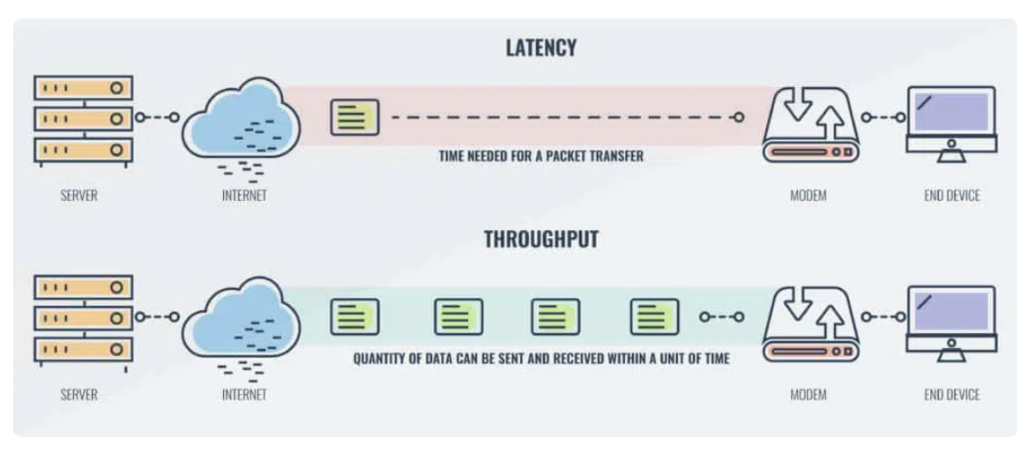

Latency is measured in milliseconds.

Latency is one of the most reliable ways to measure the speed of your network. Latency is measured in milliseconds. In the event that you want to measure the amount of data traveling from one point to another, you would use network throughput. Throughput is measured in bits per second (bps) in the form of megabits per second (Mbps) or gigabits per second (Gbps). Throughput is the rate at which packets reach their destination successfully within a specific time period. While you can calculate throughput numbers, it is simpler to measure it with bps rather than running a calculation.

Here we will consider the latency as time taken to complete a task. Say the Latency is T , we will divide the task into sub task

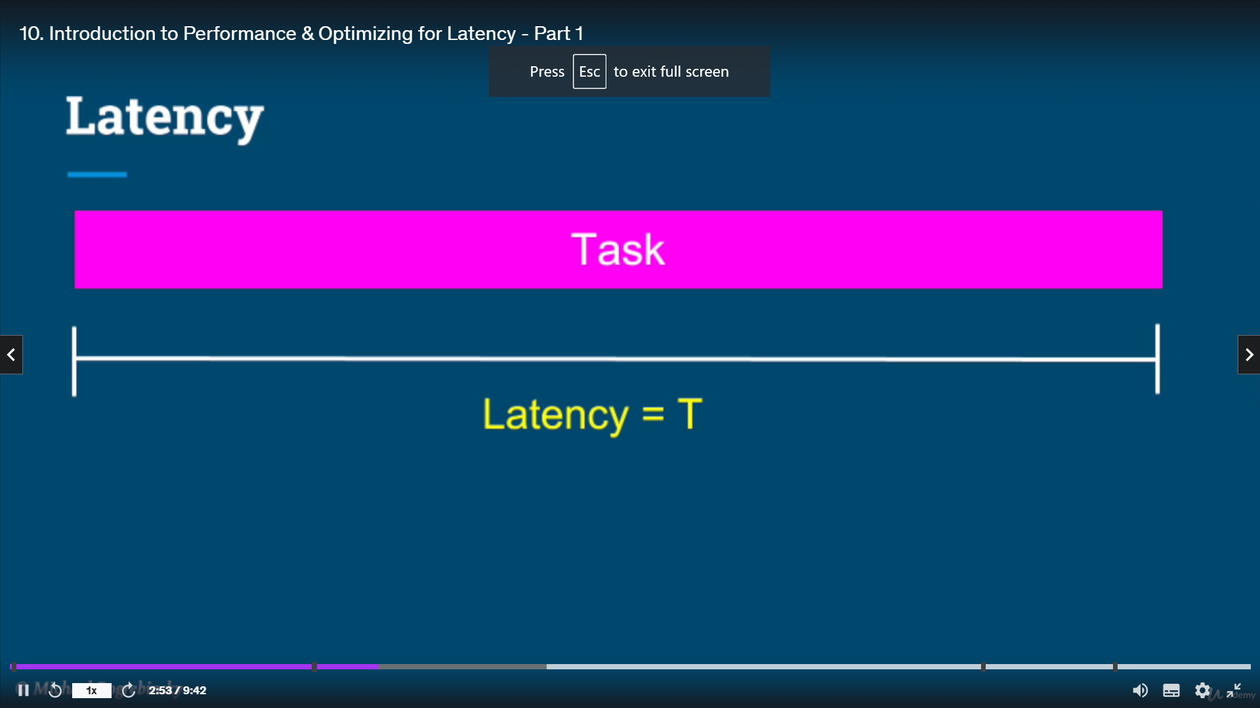

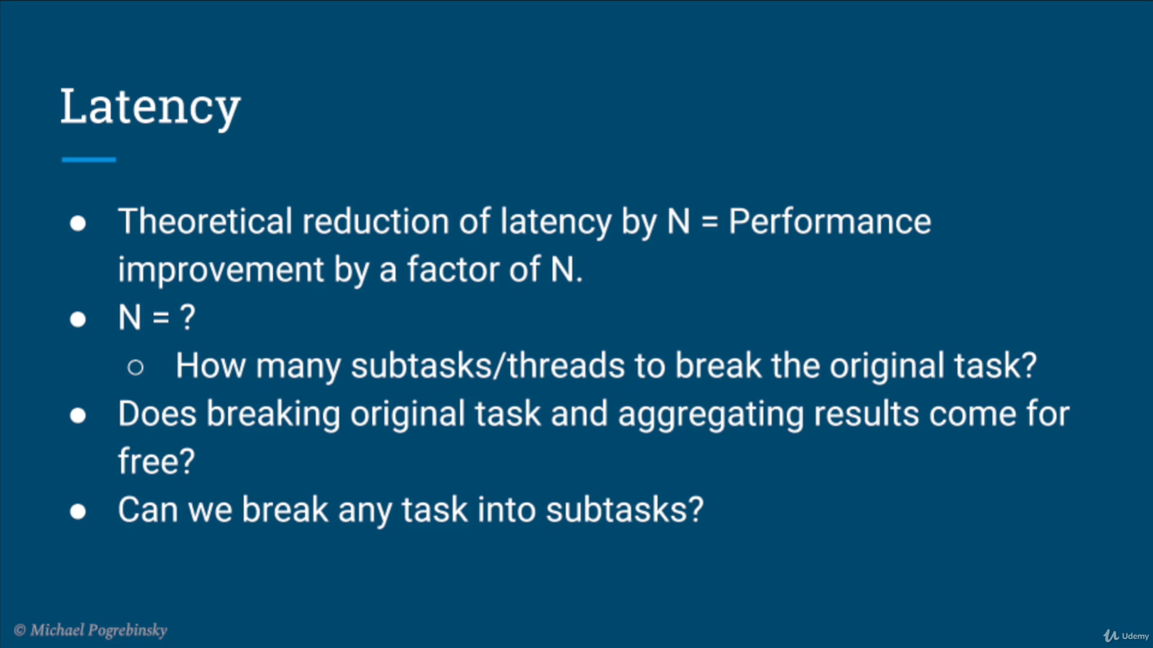

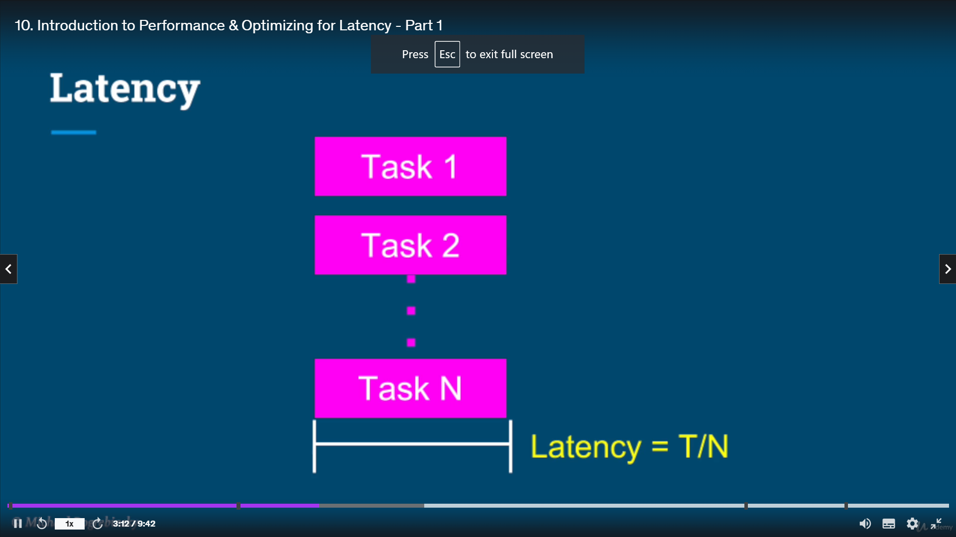

If there an N cores available and can parallel run all the thread it reduces the Latency by a factor of N. If we add 1 more threads and there are only N cores and (N+1) threads and 1 threads remain idle its going to impact the performance significantly. Adding just a single additional thread will be counter productive, and in fact will reduce the performance and increase the latency. That additional thread we'll keep pushing the other threads from their core back and forth for resulting in context, switches, bad cash,

performance, and extra memory consumption.

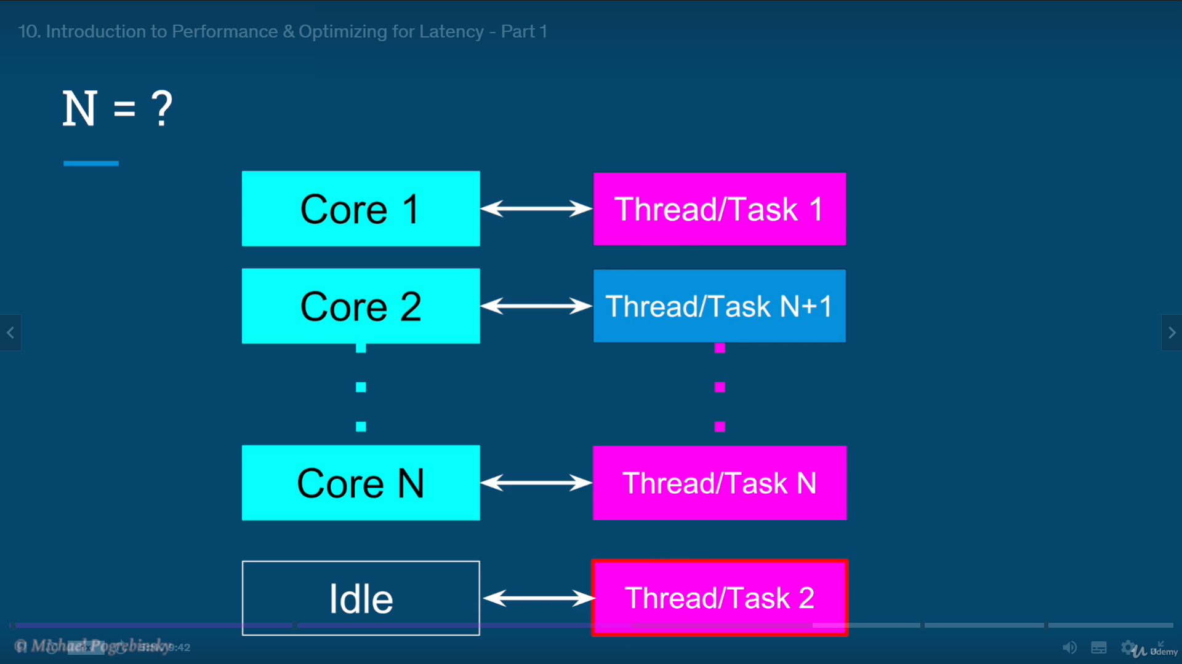

The reason for that is the reduction in latency is a result of running

these sub tasks fully in parallel. And only if we run this tasks on different cores, we can truly run them in parallel to each other. Theoretically, if nothing else of significance is running on the same computer, the operating system will do the best it can to schedule every task on a different core, utilizing its hardware the best it can and give us the optimal performance.

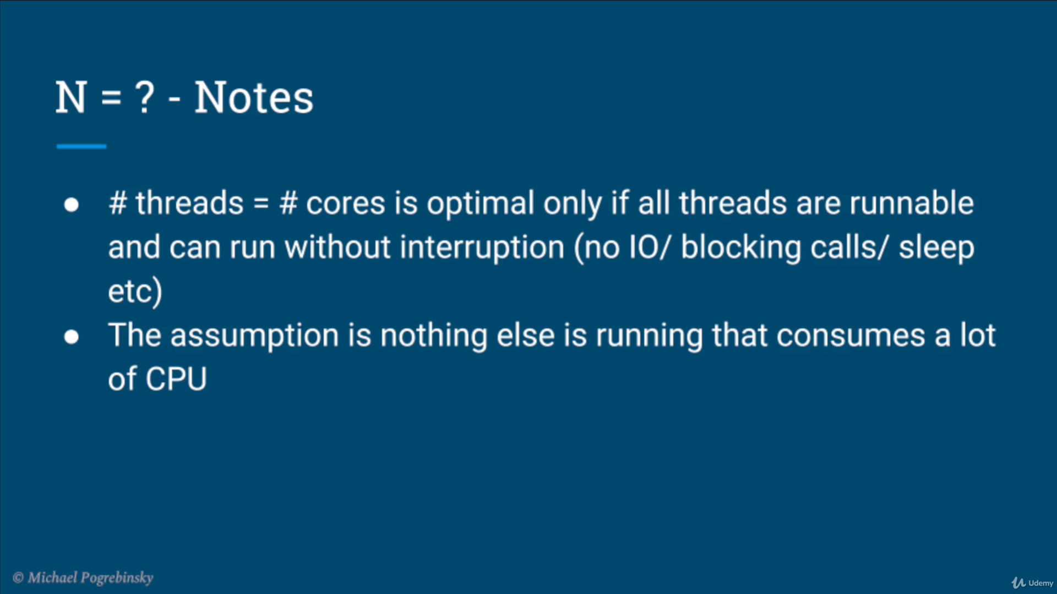

The formula of number of threads equals number of cores, is optimal only if all

the threads can run their corresponding sub tasks without interruption.

In other words, all threads are in a runnable state the whole time.

That means no, I O and no blocking calls

And the reality it's rarely the case. So the results will be rarely optimal, but we can be close to that. The second point iswe assume that nothing else is running on that system that consumes a lot of CPU, which is almost never the case, but if we have a dedicated server for our application, then the other processes and the OS itself

should have almost a negligible impact comparing to our applications threads.

So again, we will never achieve the optimal utilization, but we can get close to that.

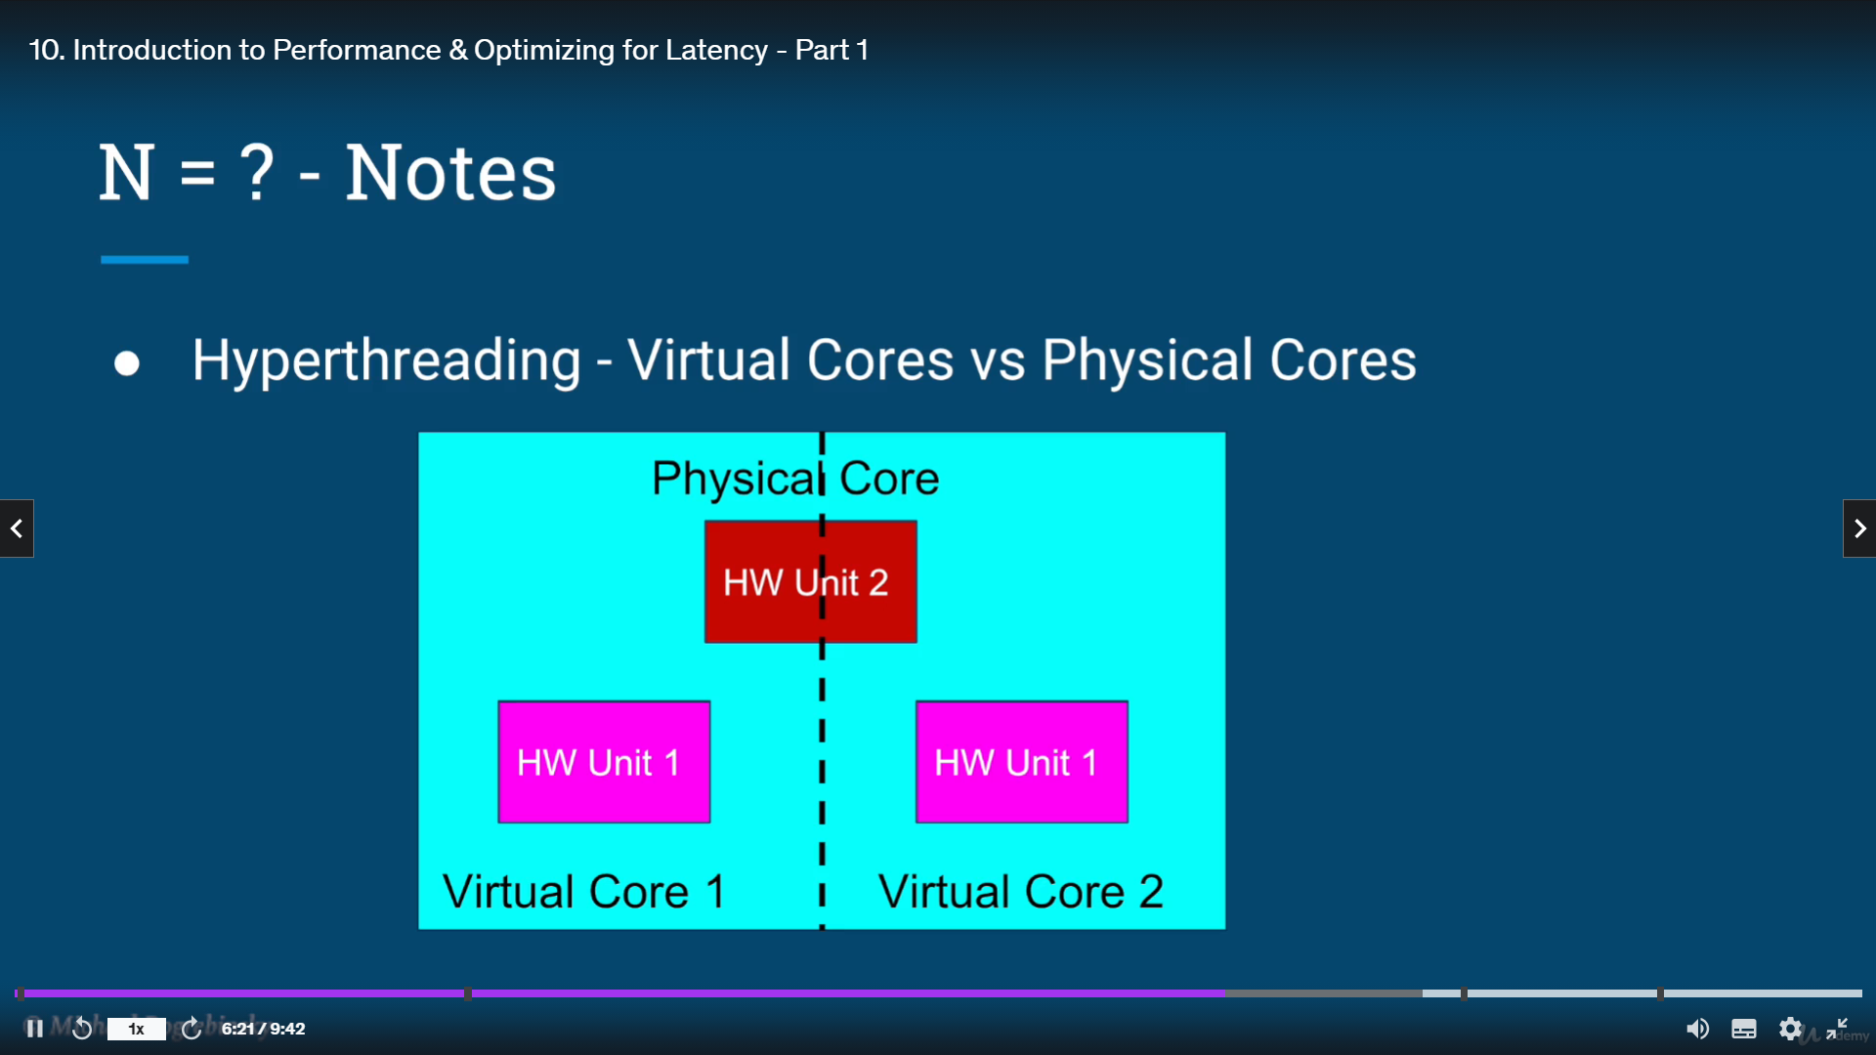

The last note is in fact, most computers today use what's called hyper-threading.

It means that a single physical core can run two threads at the time that

is achieved by having some hardware units in a physical core duplicated.

So the two threads can run in parallel and some hardware units are shared.

So we can never run all threads a hundred percent in parallel to each other.

But again, we can get close to that.

The next question we ask was the cost of breaking a single task into many and aggregating the result at the very minimum. If the task is easily broken into multiple, we're going to have to accept some inherent costs associated with that procedure ,

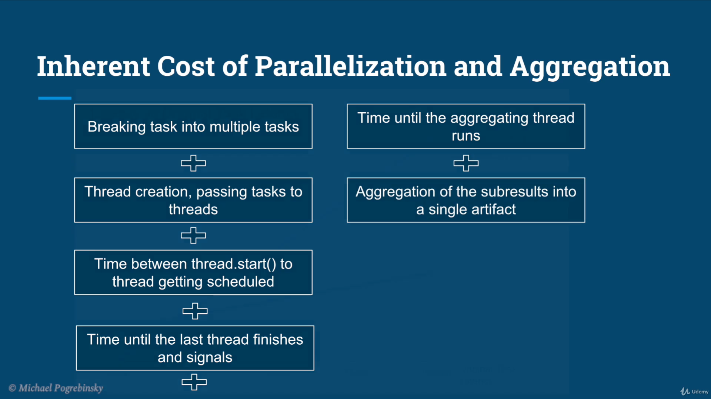

it's going to be the cost of doing some calculations in

breaking the task into smaller segments, cost of creating the threads, passing

the tasks to them and starting them.

Then there's the time that it takes for the threads to actually be scheduled by

the operating system and start running to get the results we need to wait until the

last of the threads finishes and signals to aggregating thread that it's done.

Not all the sub tasks may be the same length and not all of

them start in the same time.

Also again, we have the time until the aggregating thread gets the

signal and starts running again. And lastly aggregating the sub tasks into a single artifact also has some inherent cost.

So if we plot the latency of our solution versus don't regional task latency,

we can see that the multithreaded solution has a constant penalty.

We have to pay for any size of task, but the longer and heavier the original

task is the more worthwhile it is to break in the running in parallel.

And the point where we need to decide if the task is worth parallelizing, is

that intersection of the multithreaded solution and the single threaded solution.

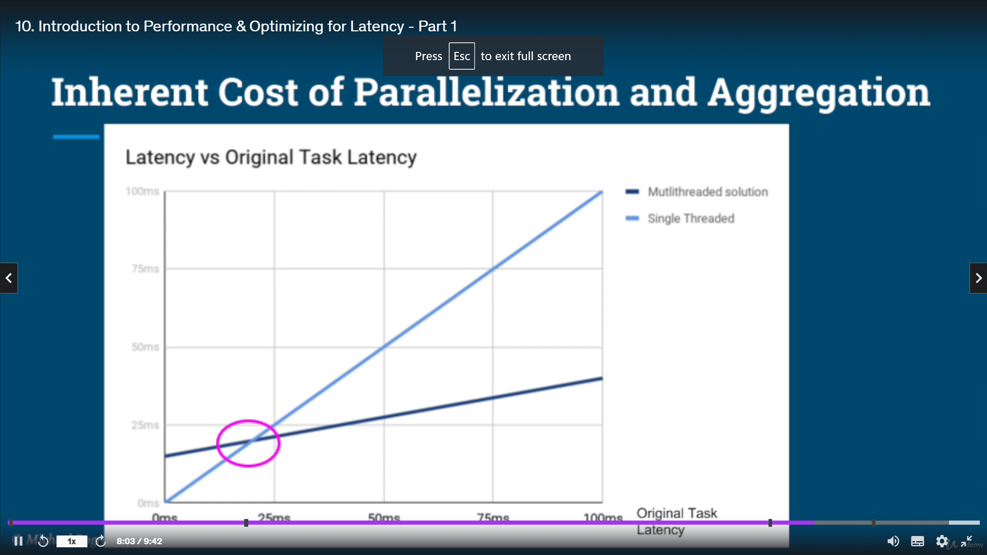

The key take away from this graph is that small and trivial tasks are just not worth

breaking and they're running in parallel. The answer to that last question, whether we can always break any task into sub tasks, sadly is no, not every task can be broken into multiple independent tasks that can run in parallel.

We can really classify the tasks into three types,

the tasks that are inherently paralyzable and can be easily broken into sub tasks.

The unbreakable tasks that we're just forced to run on a single thread

from start to finish and probably the most common tasks, which can

be partially broken into sub tasks. And partially we have to run sequentially.

Let's summarize the key points.

First of all, we'll learn that performance is a somewhat broad term.

And for every use case, we need to define what performance metrics we're actually

interested in measuring and improving. We'll later talk about the two main performance criteria,

which we will focus on the latency and the throughput.

And the focusing on the latency we'll learn how we can reduce the

latency by breaking the task into multiple tasks and also set the

expectations on what we can and what we cannot achieve from this approach.

In the next lecture, we will explore a practical example, which will illustrate

how we can improve the performance of an algorithm by reducing it.



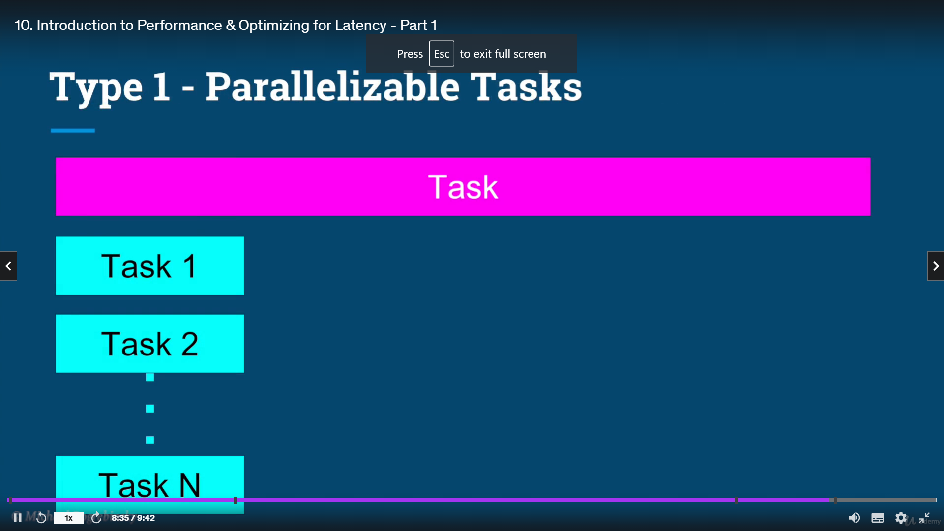

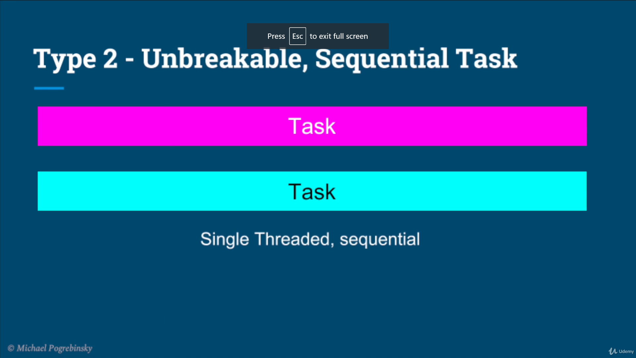

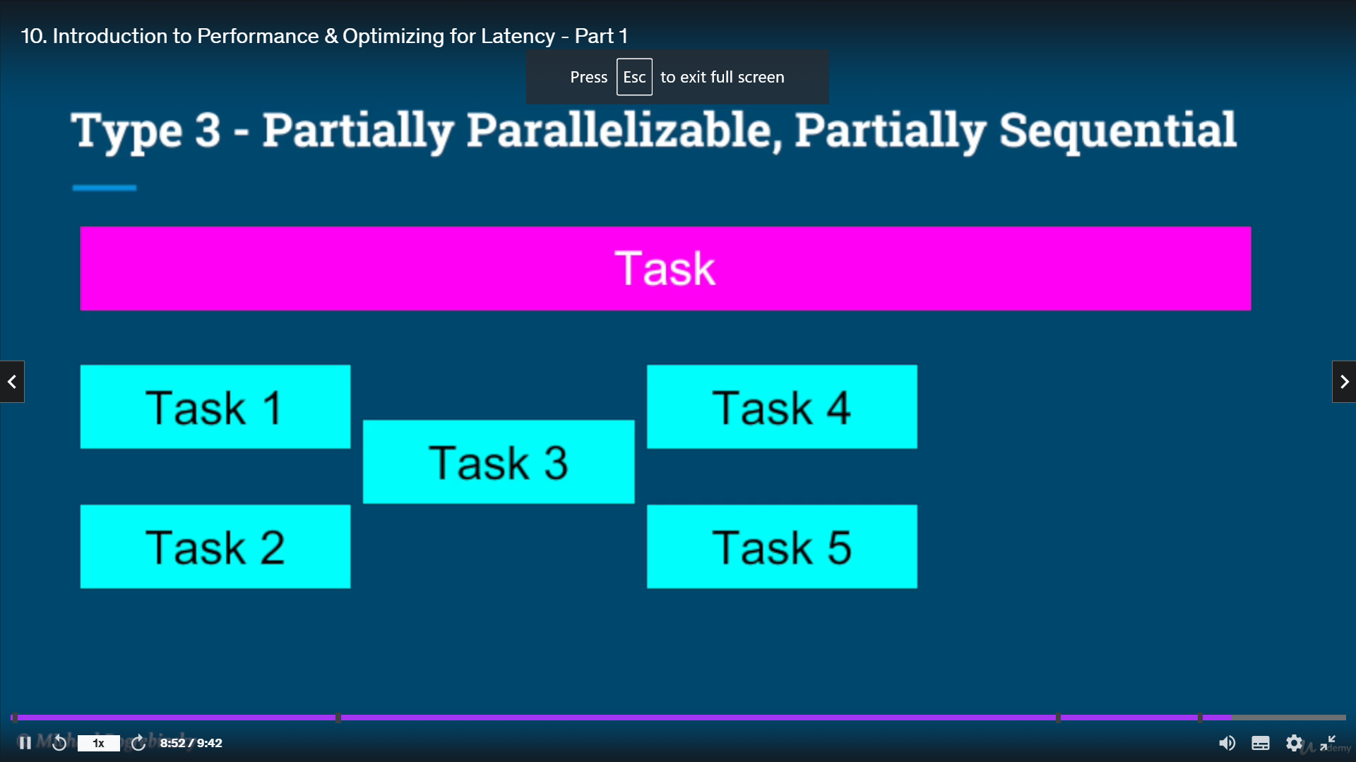

.

Performance differs depending on the case and what is the system under consideration

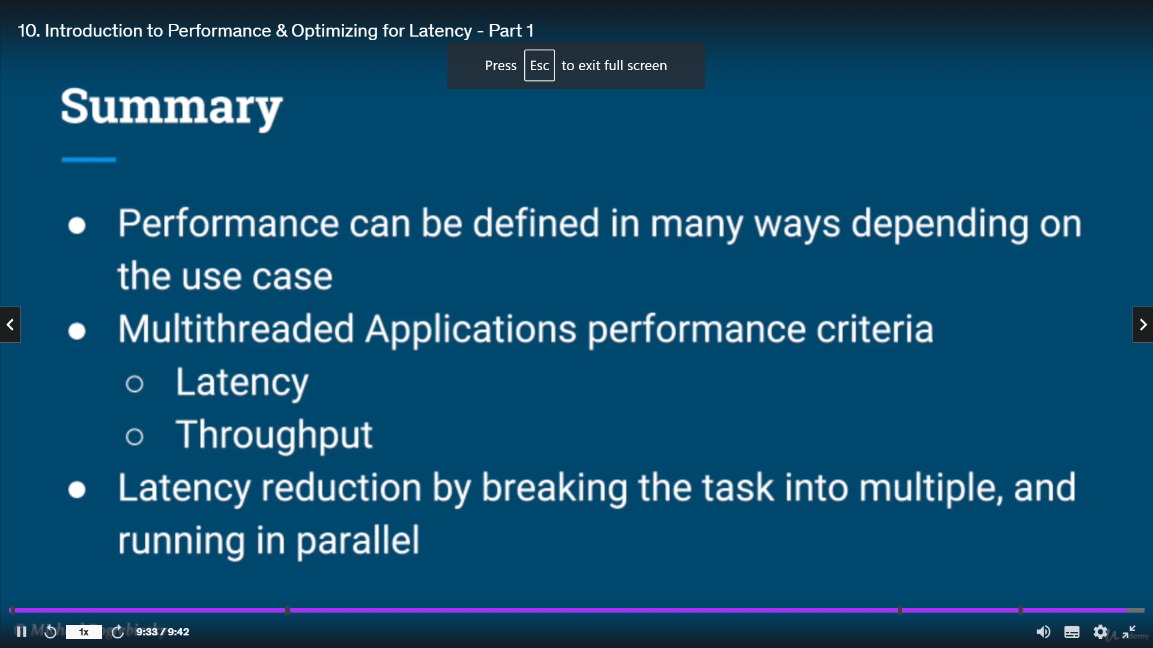



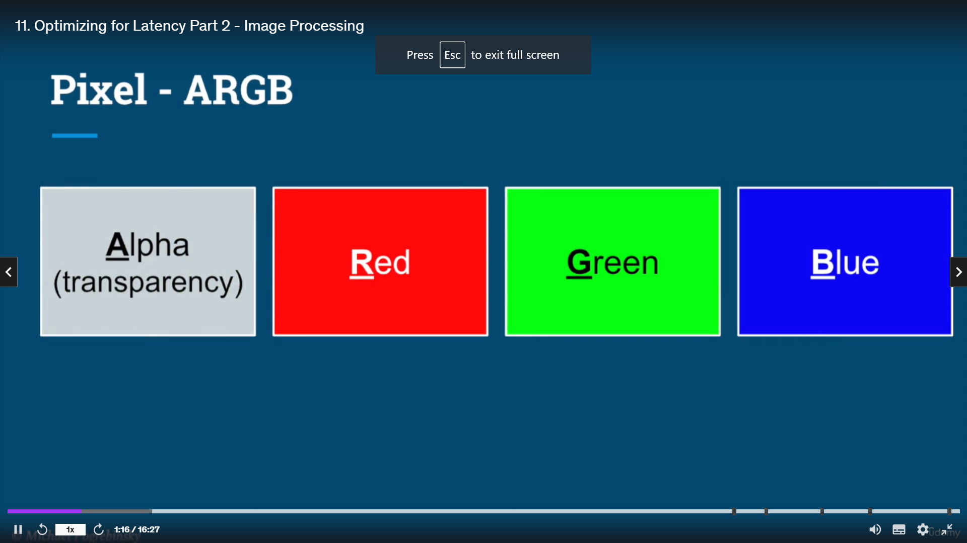 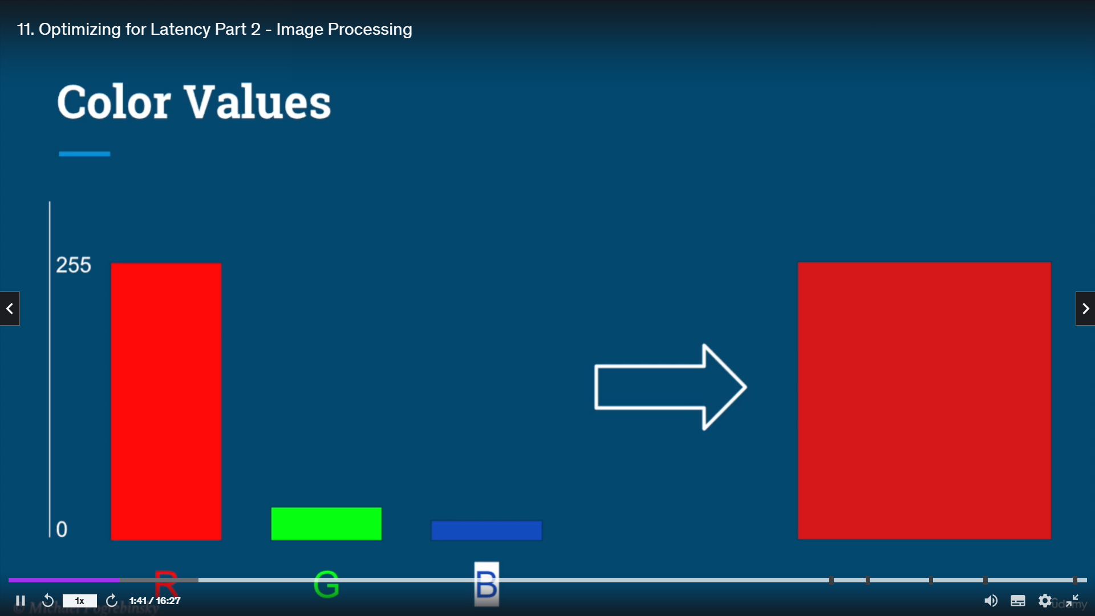

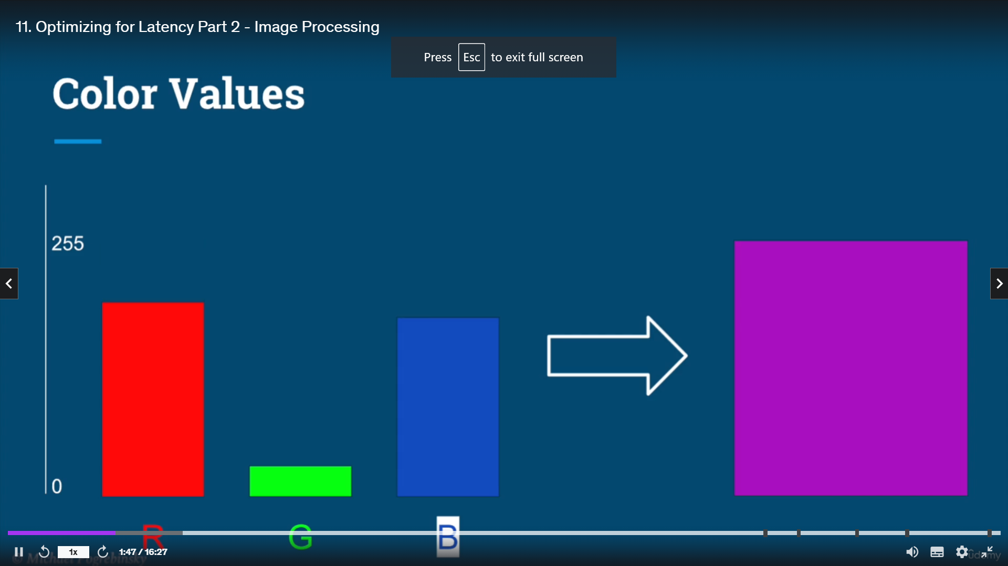

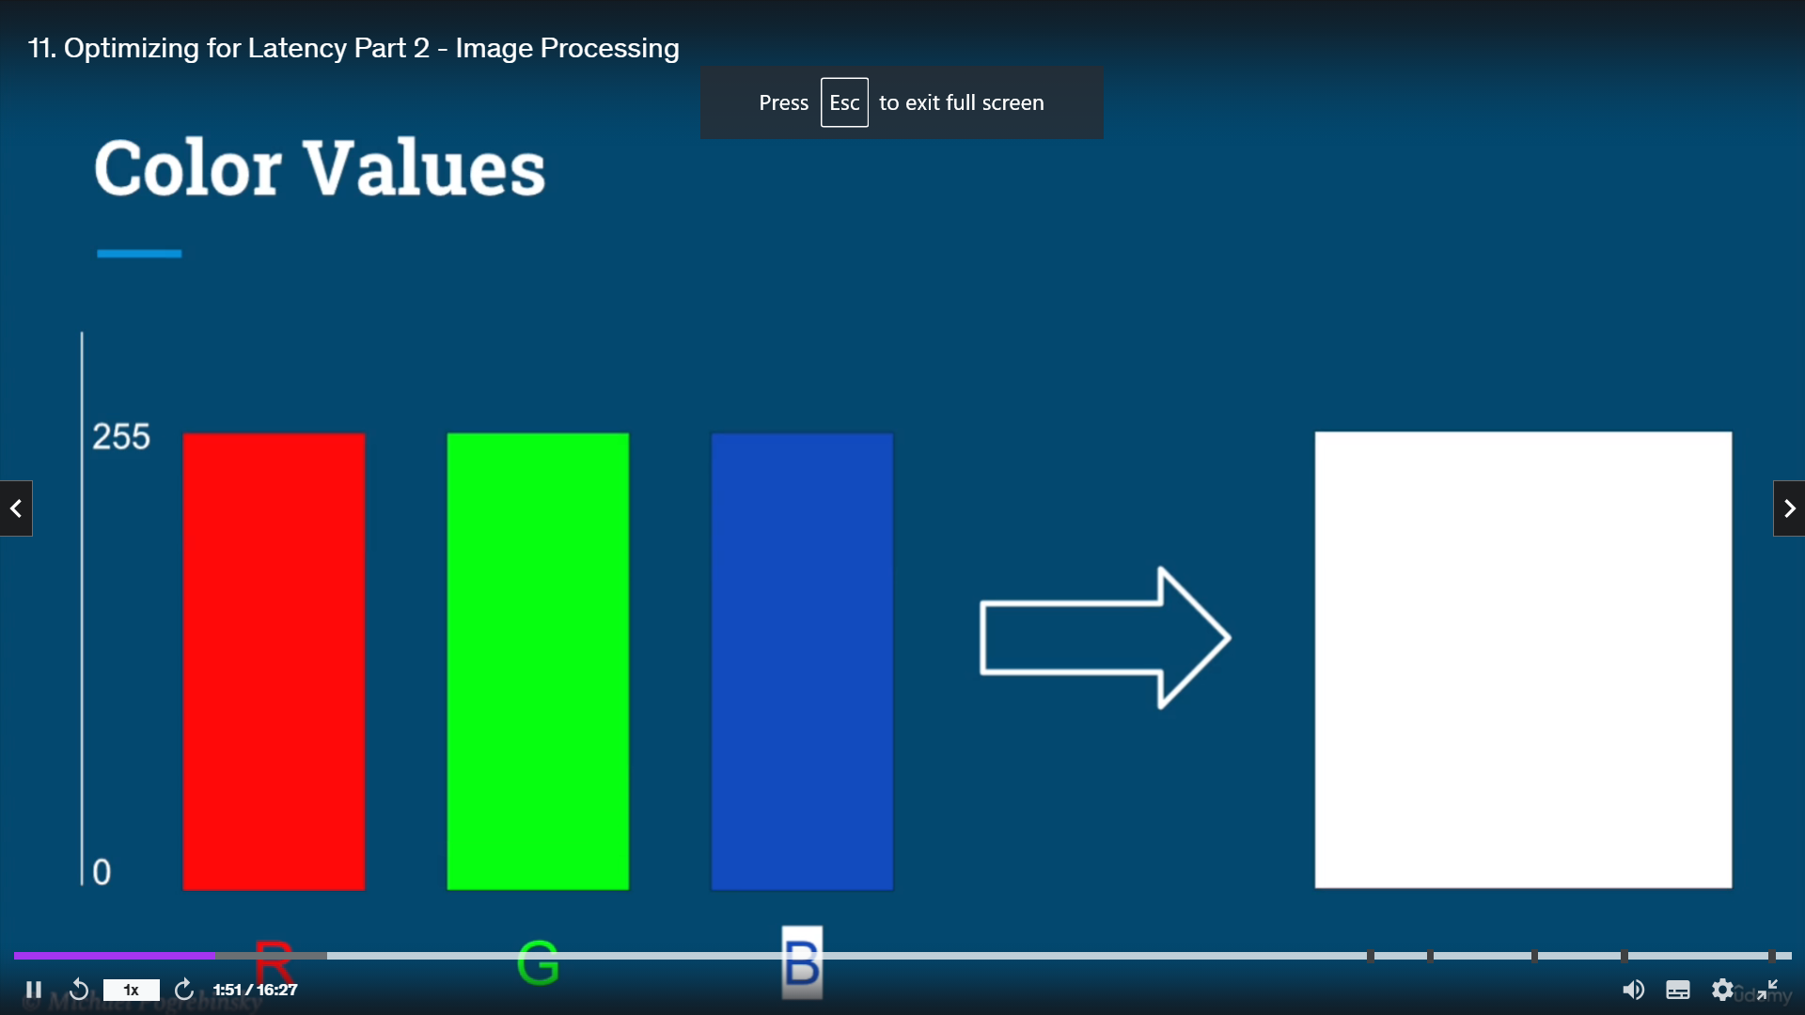 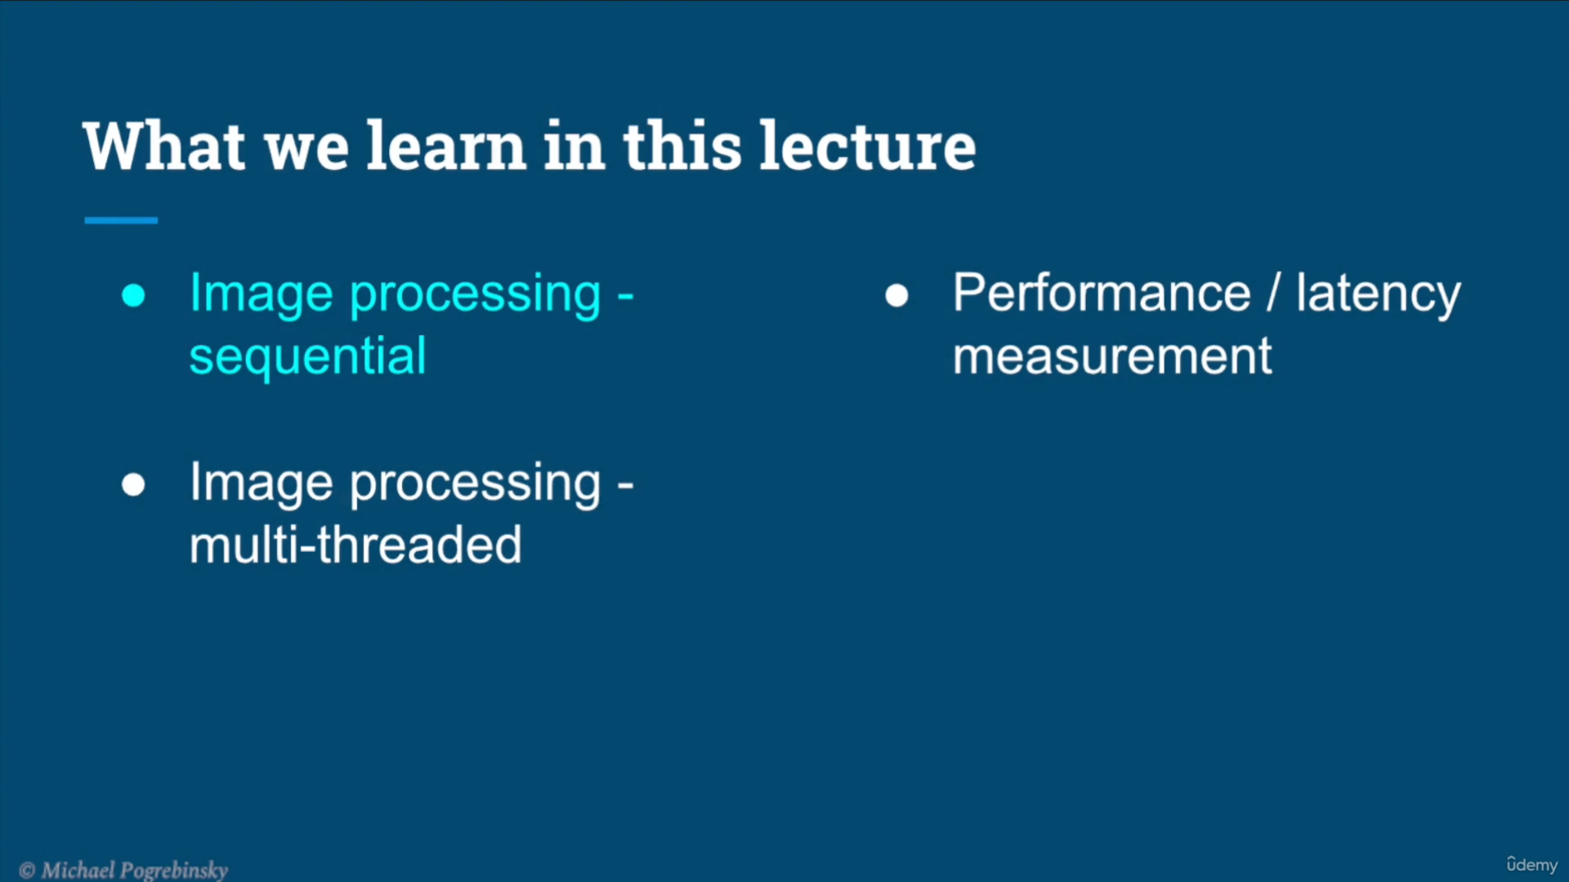

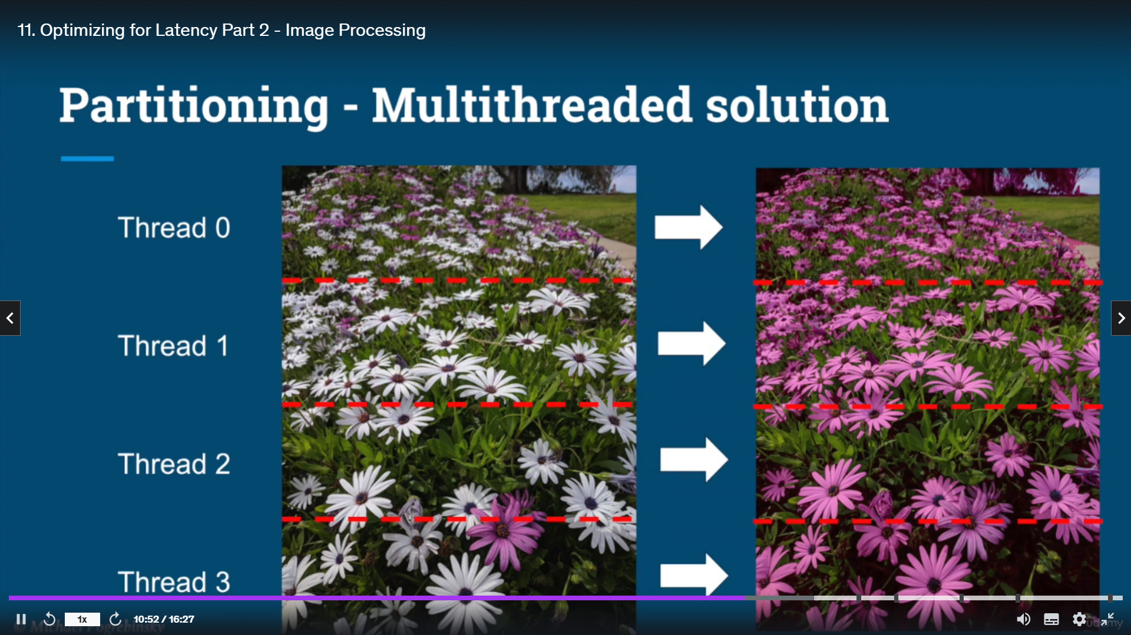

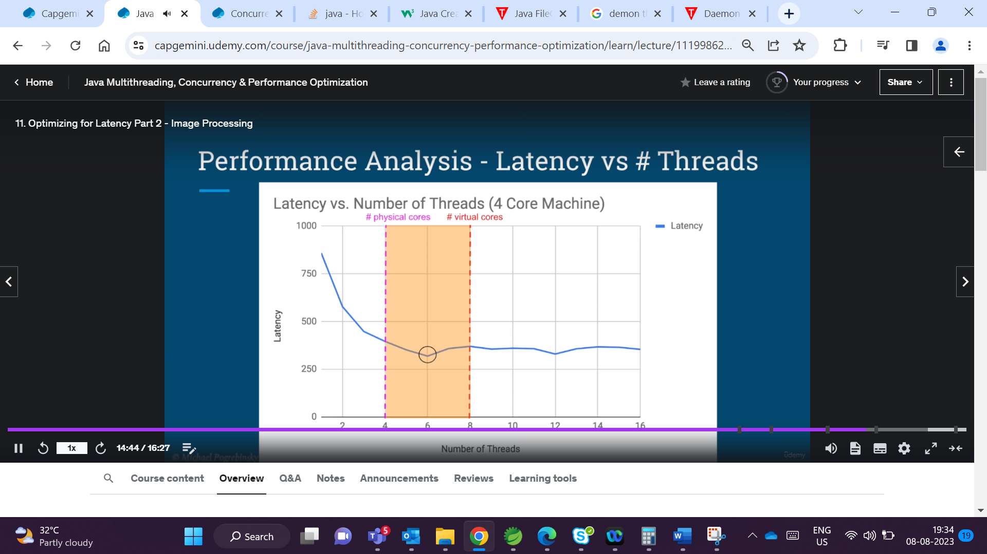 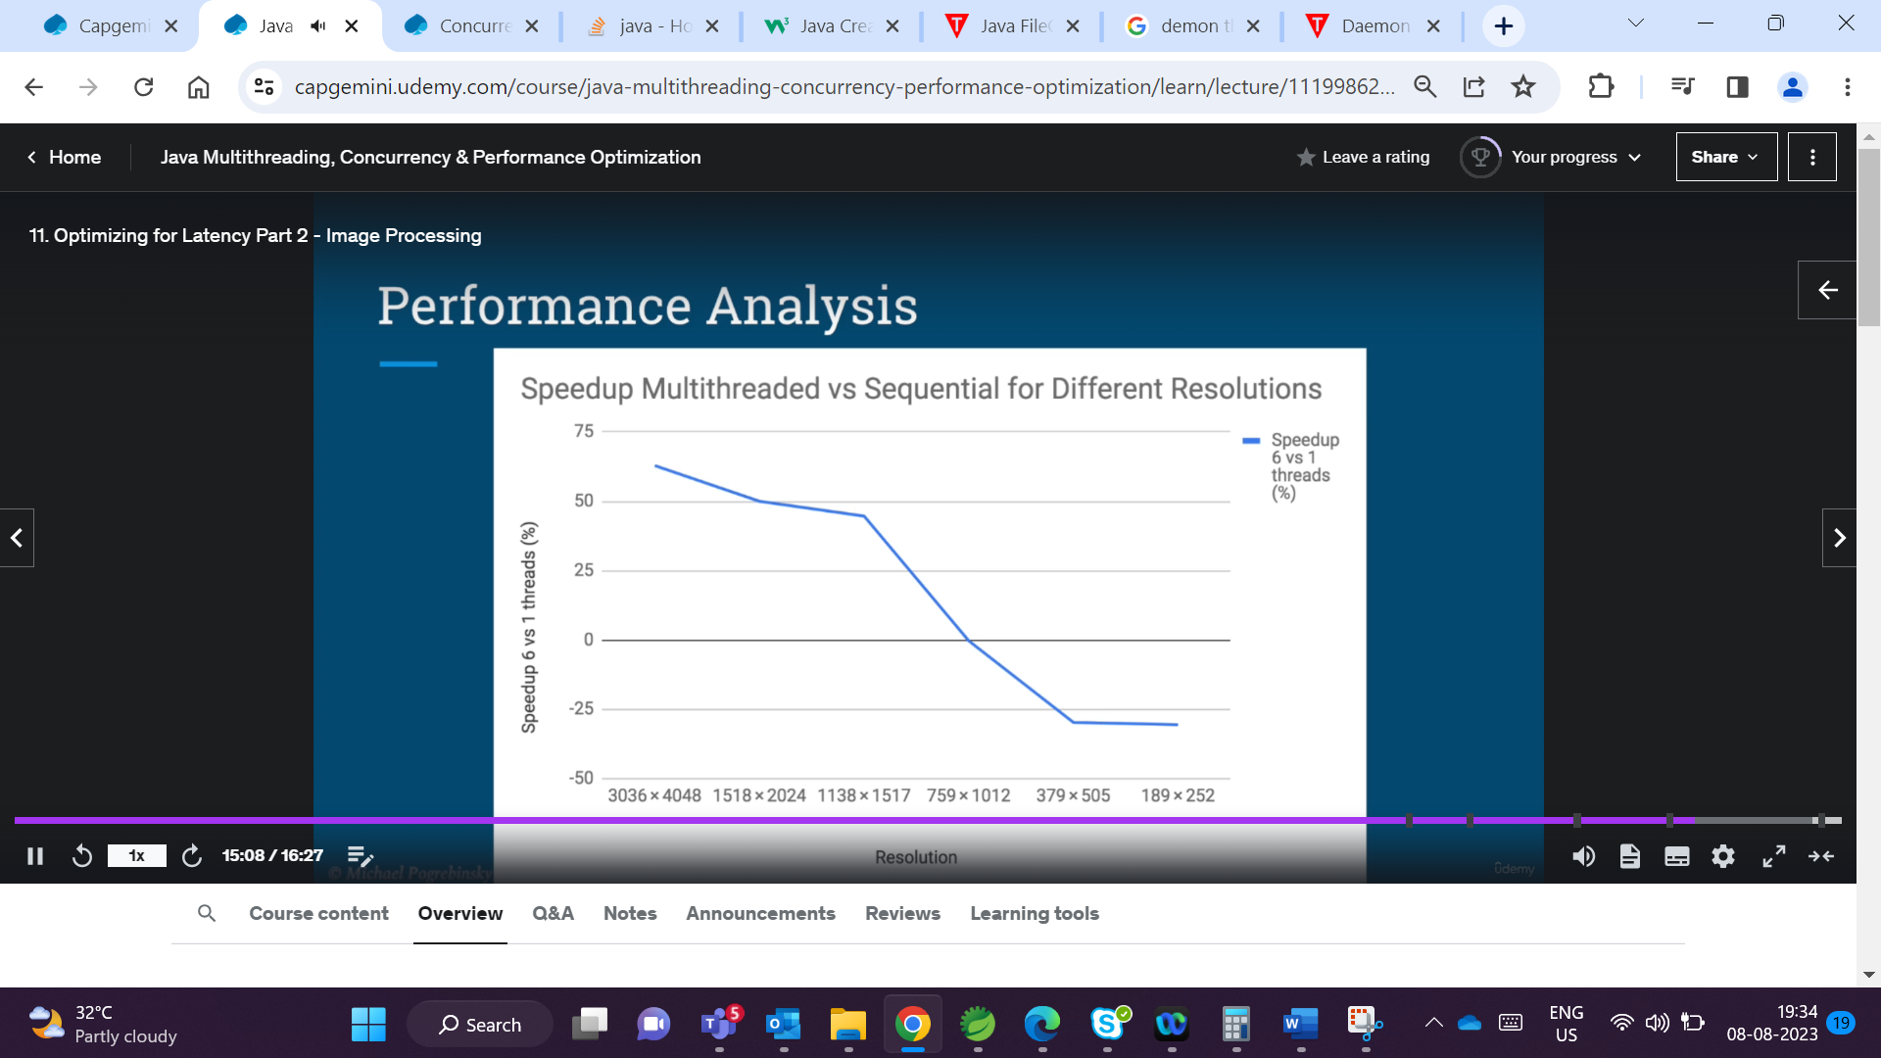

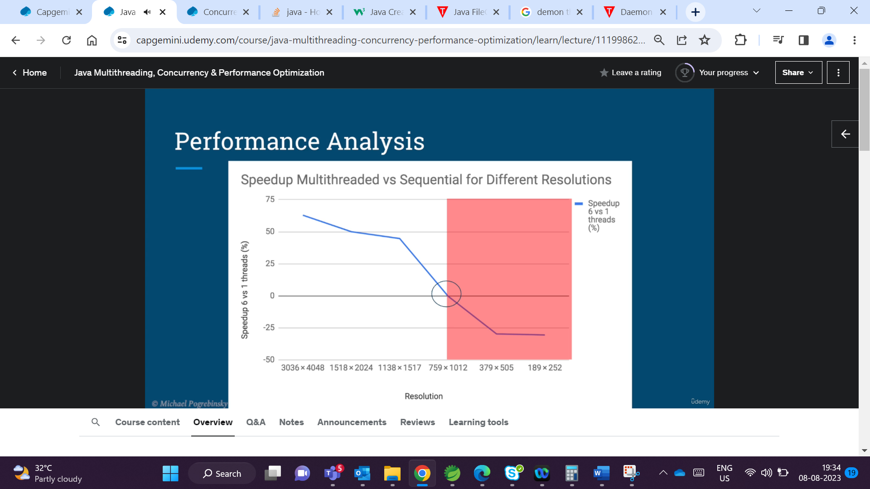

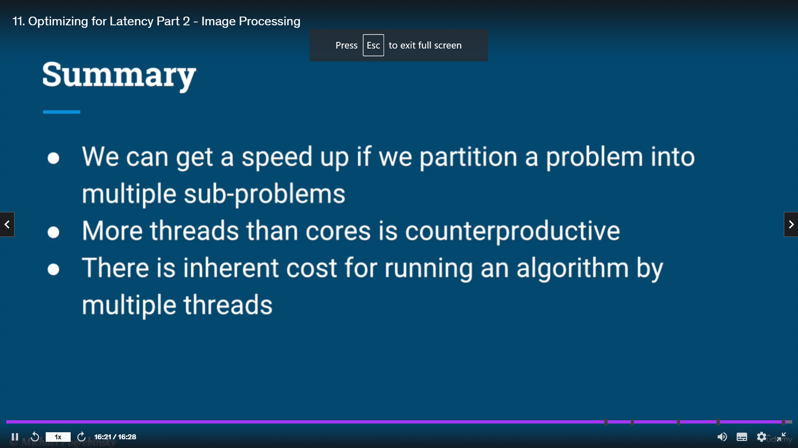

When a two threads access the same object and perfoms operations at the same time , say eg increment and decrement we are getting a problem with the output

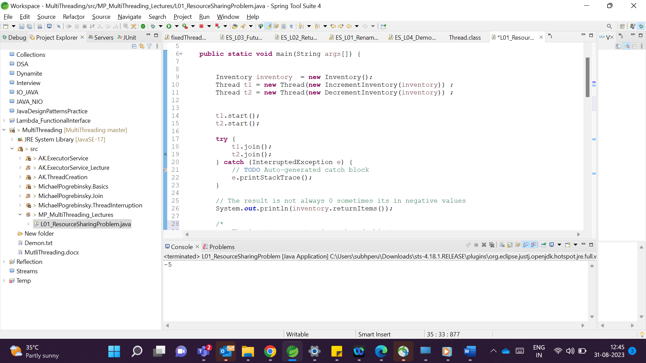

This is because the operations are not atomic

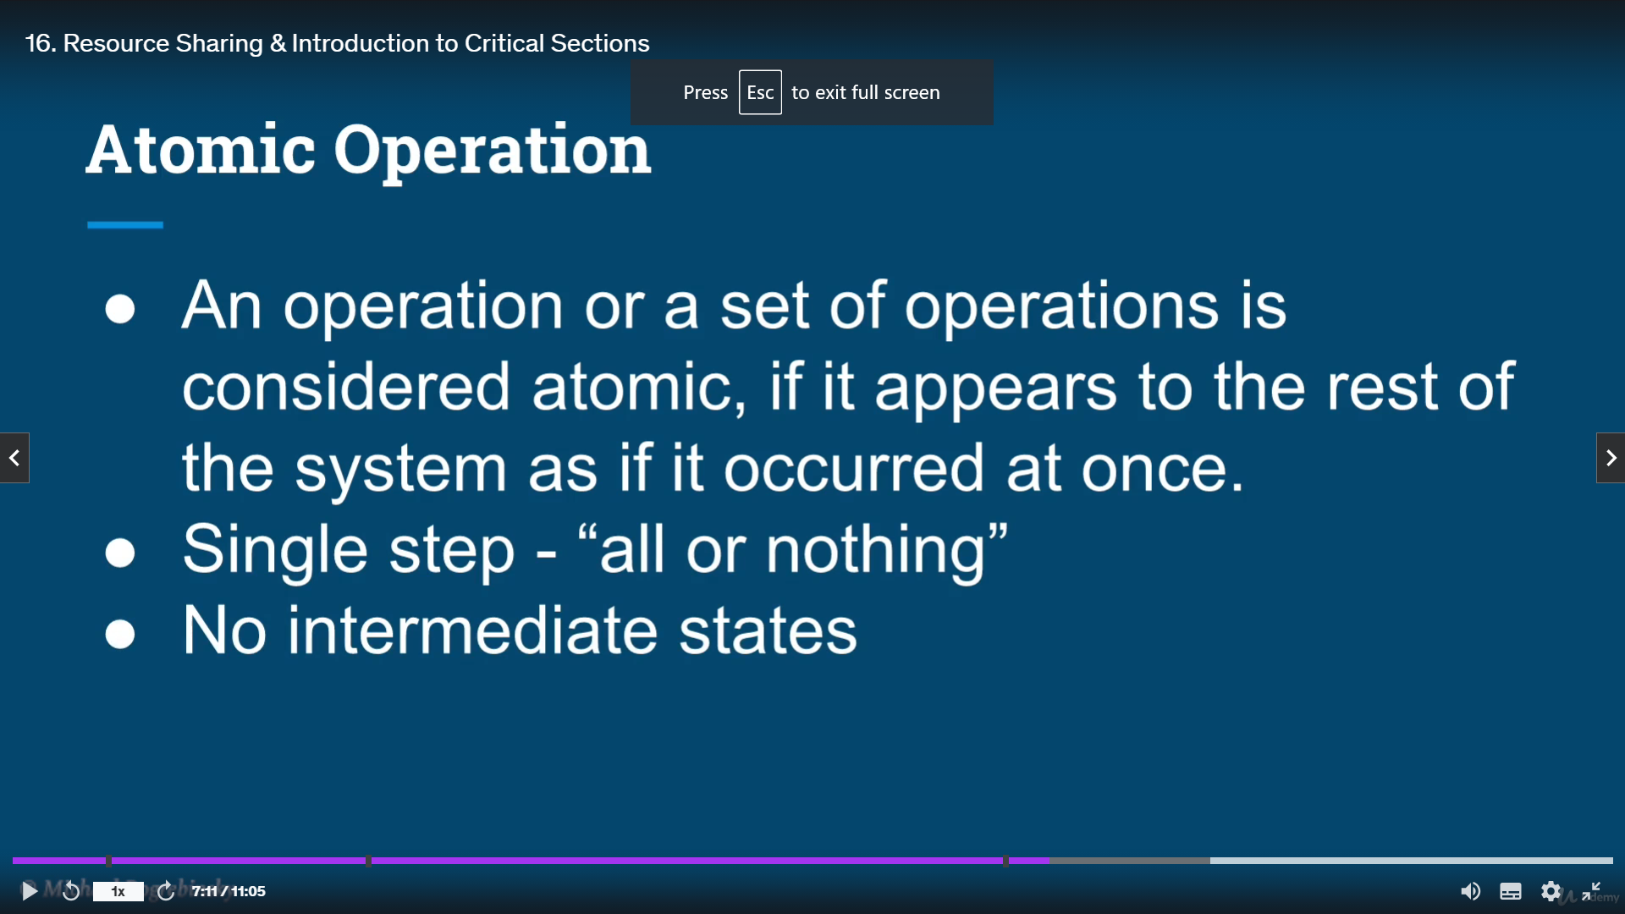

An atomic operation would be an operation or a set of operations

that appear to the rest of the system as if it happened at once.

In other words, for the rest of the system, that operation appears

as a single step all or nothing.

And there's no way for us to interrupt it in the middle and

observe an intermediate state.

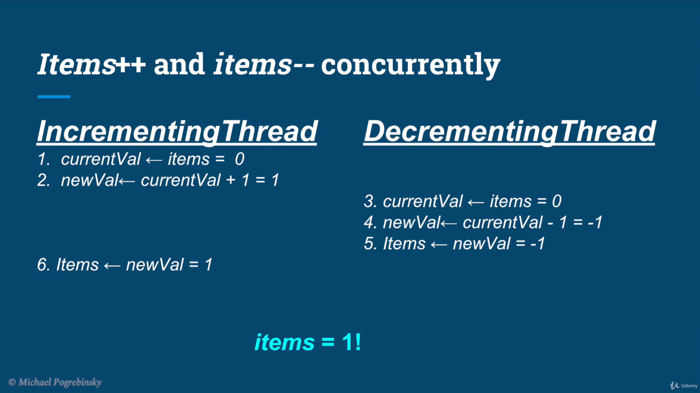

The problem could be both ways either the value could be 1 if the decrementingThread save is overridden by incrementingThread save op -1 if the opposite happens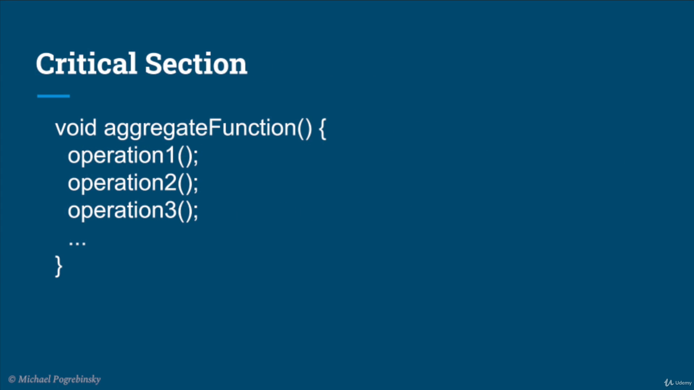

When entering the critical section no other thread should enter it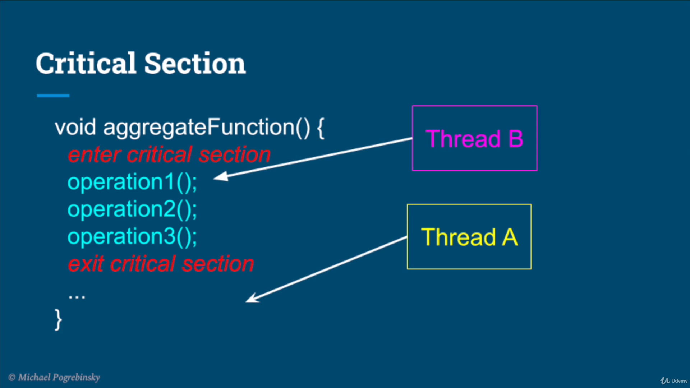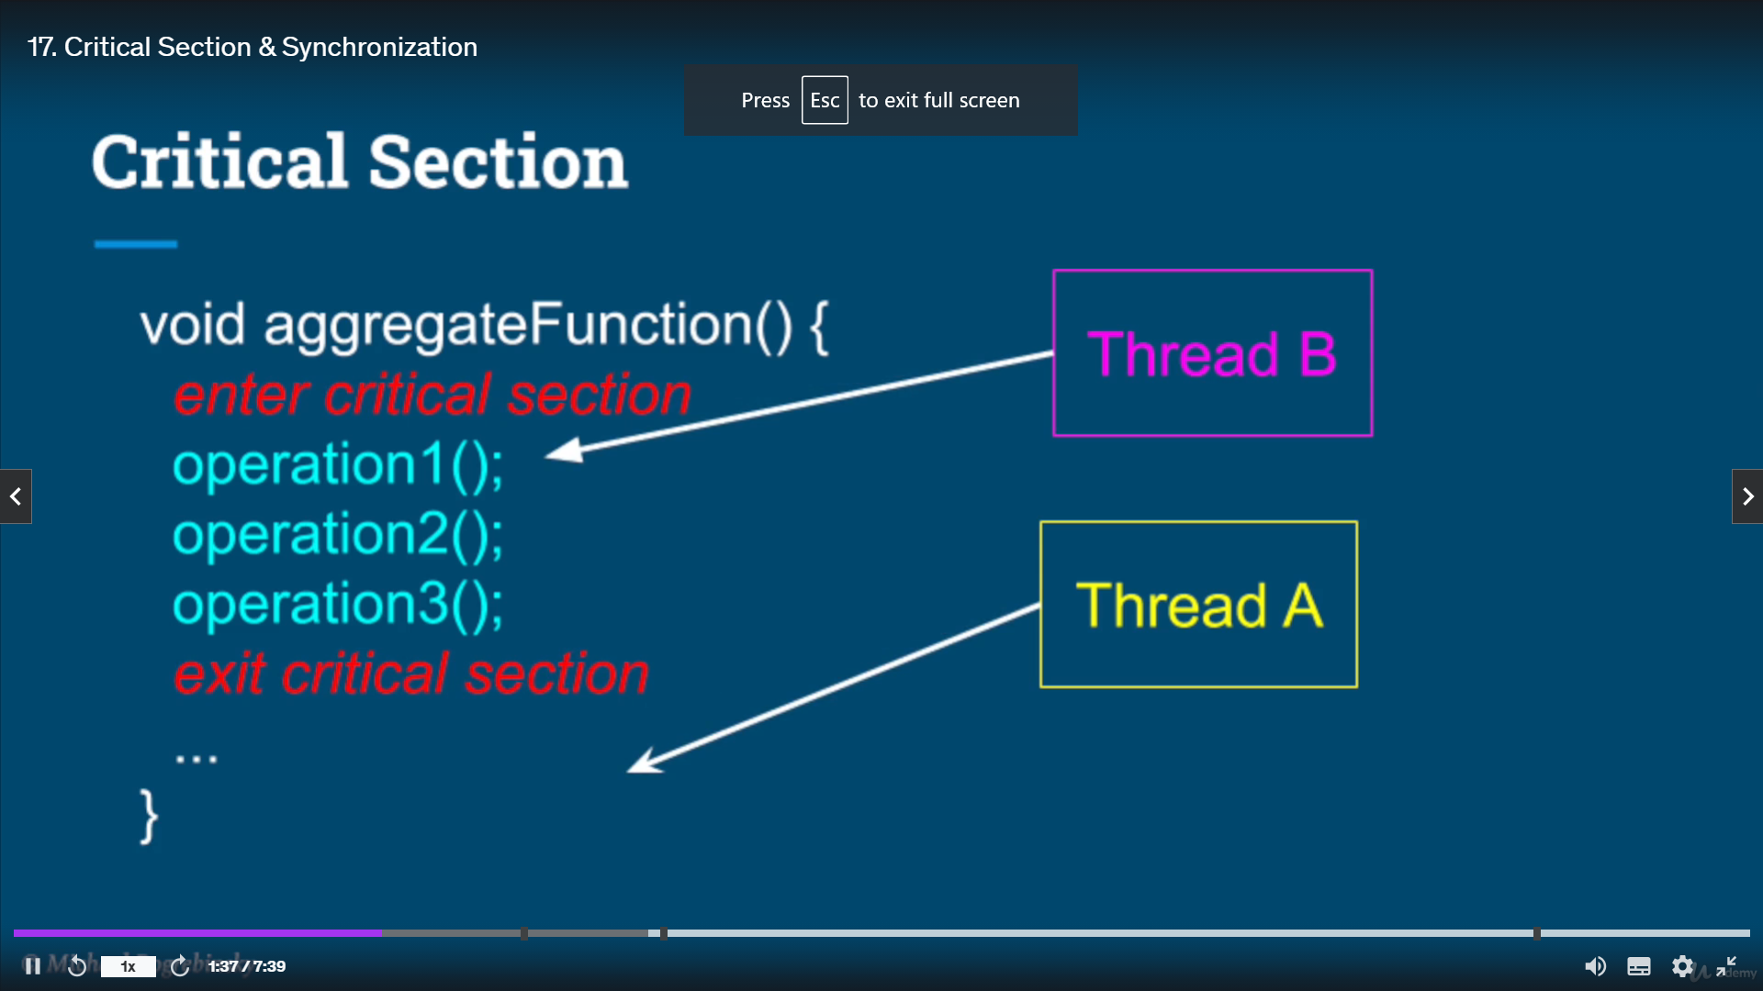

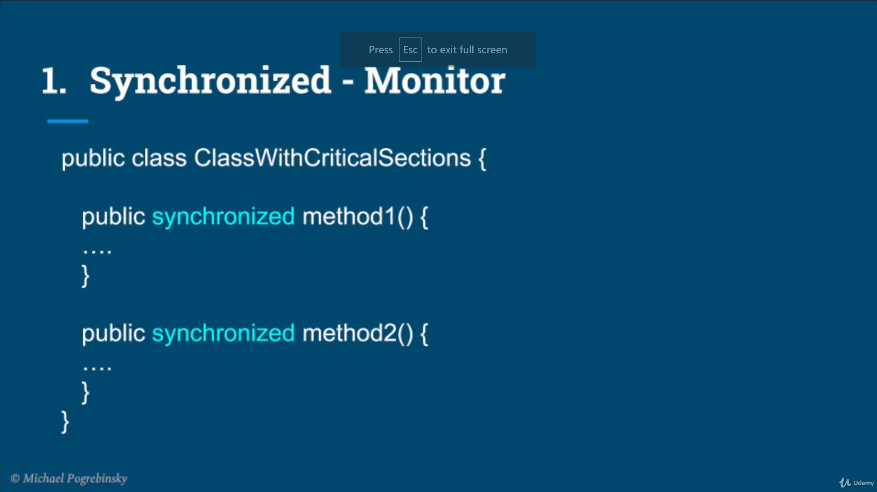

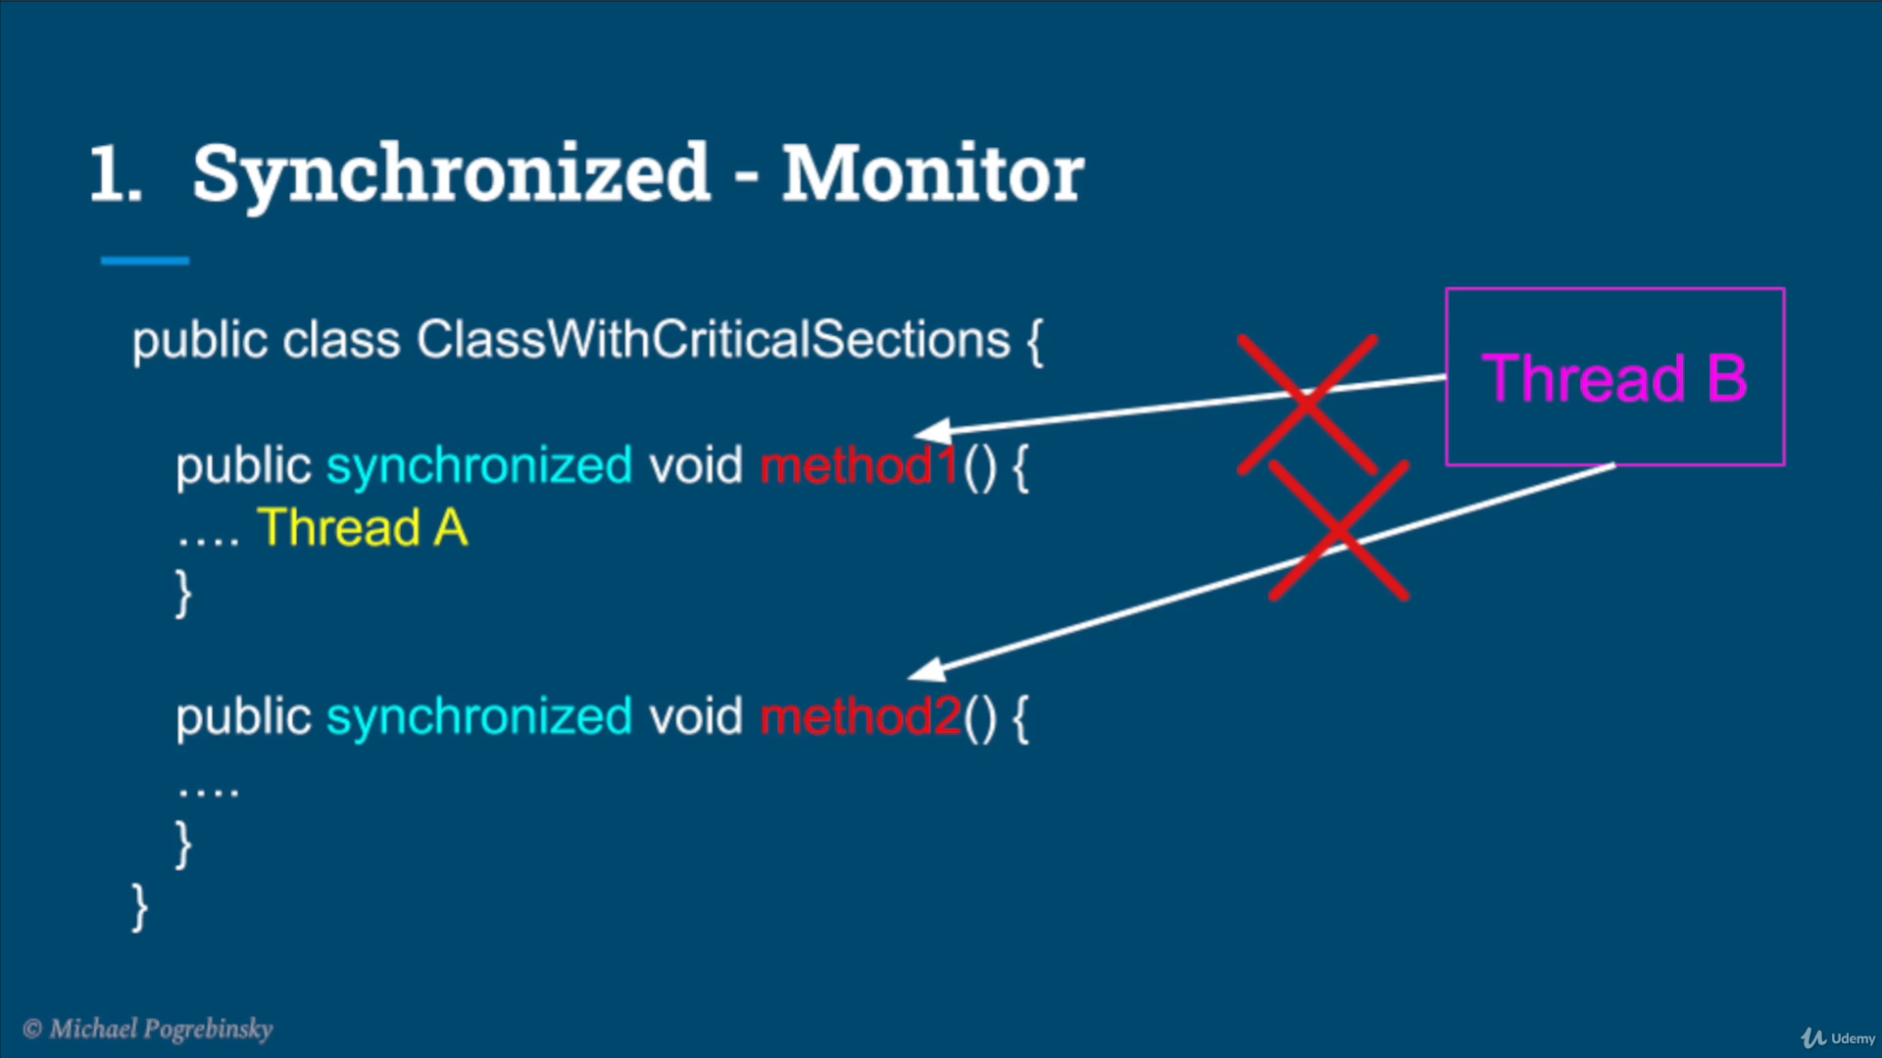

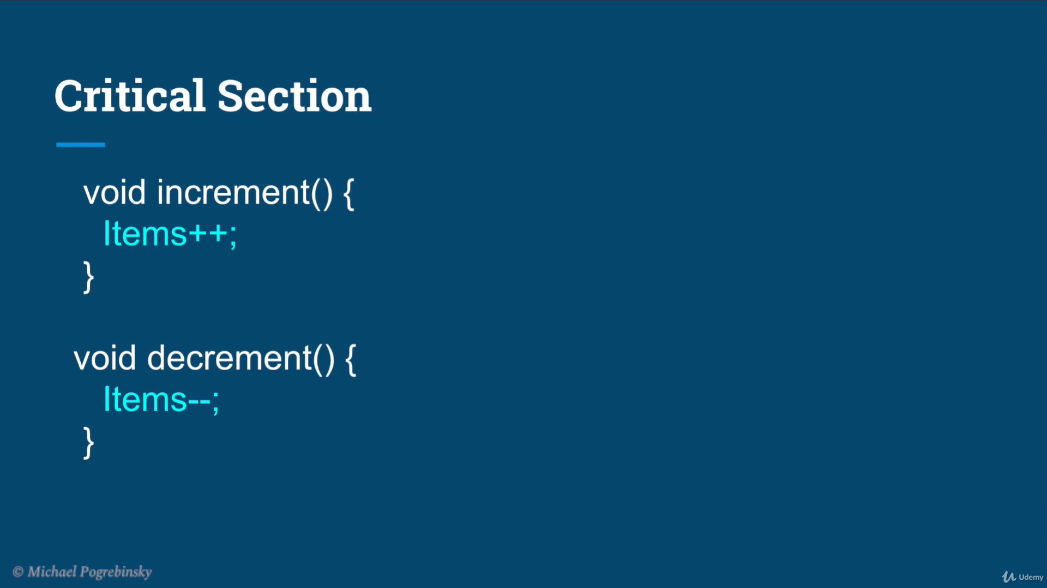

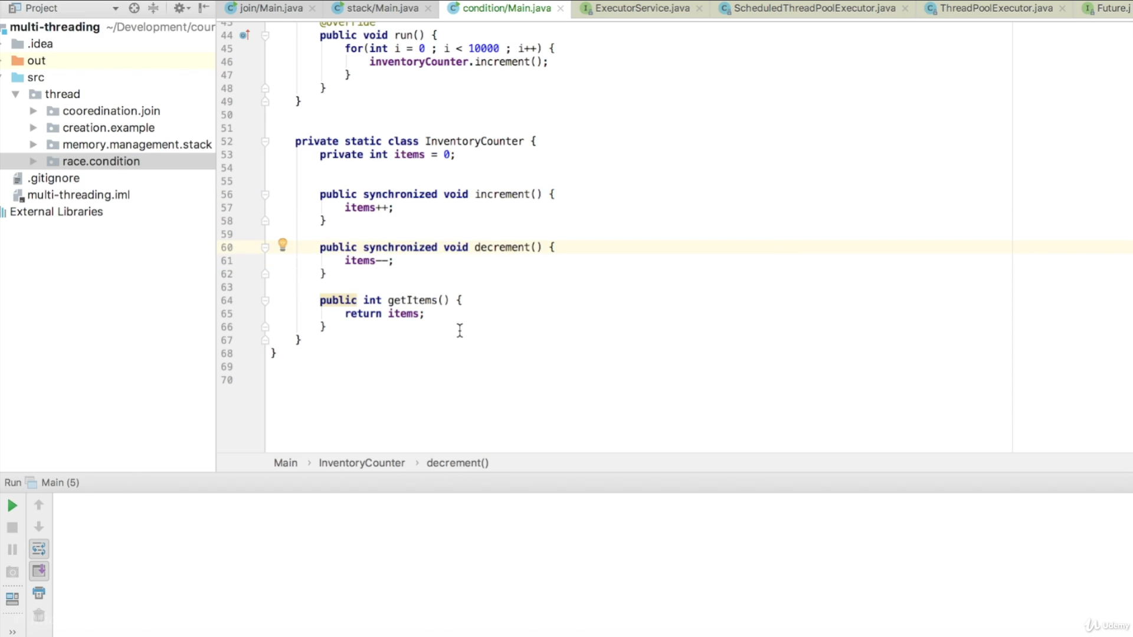

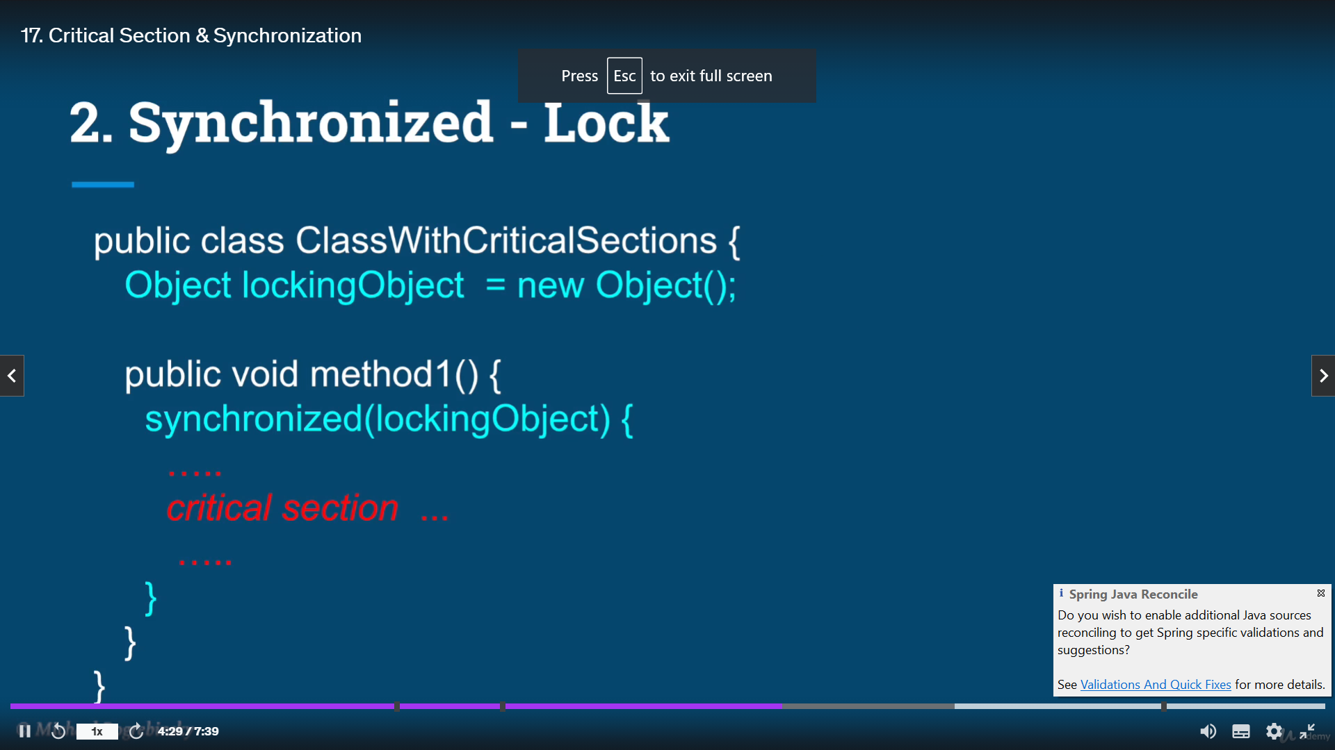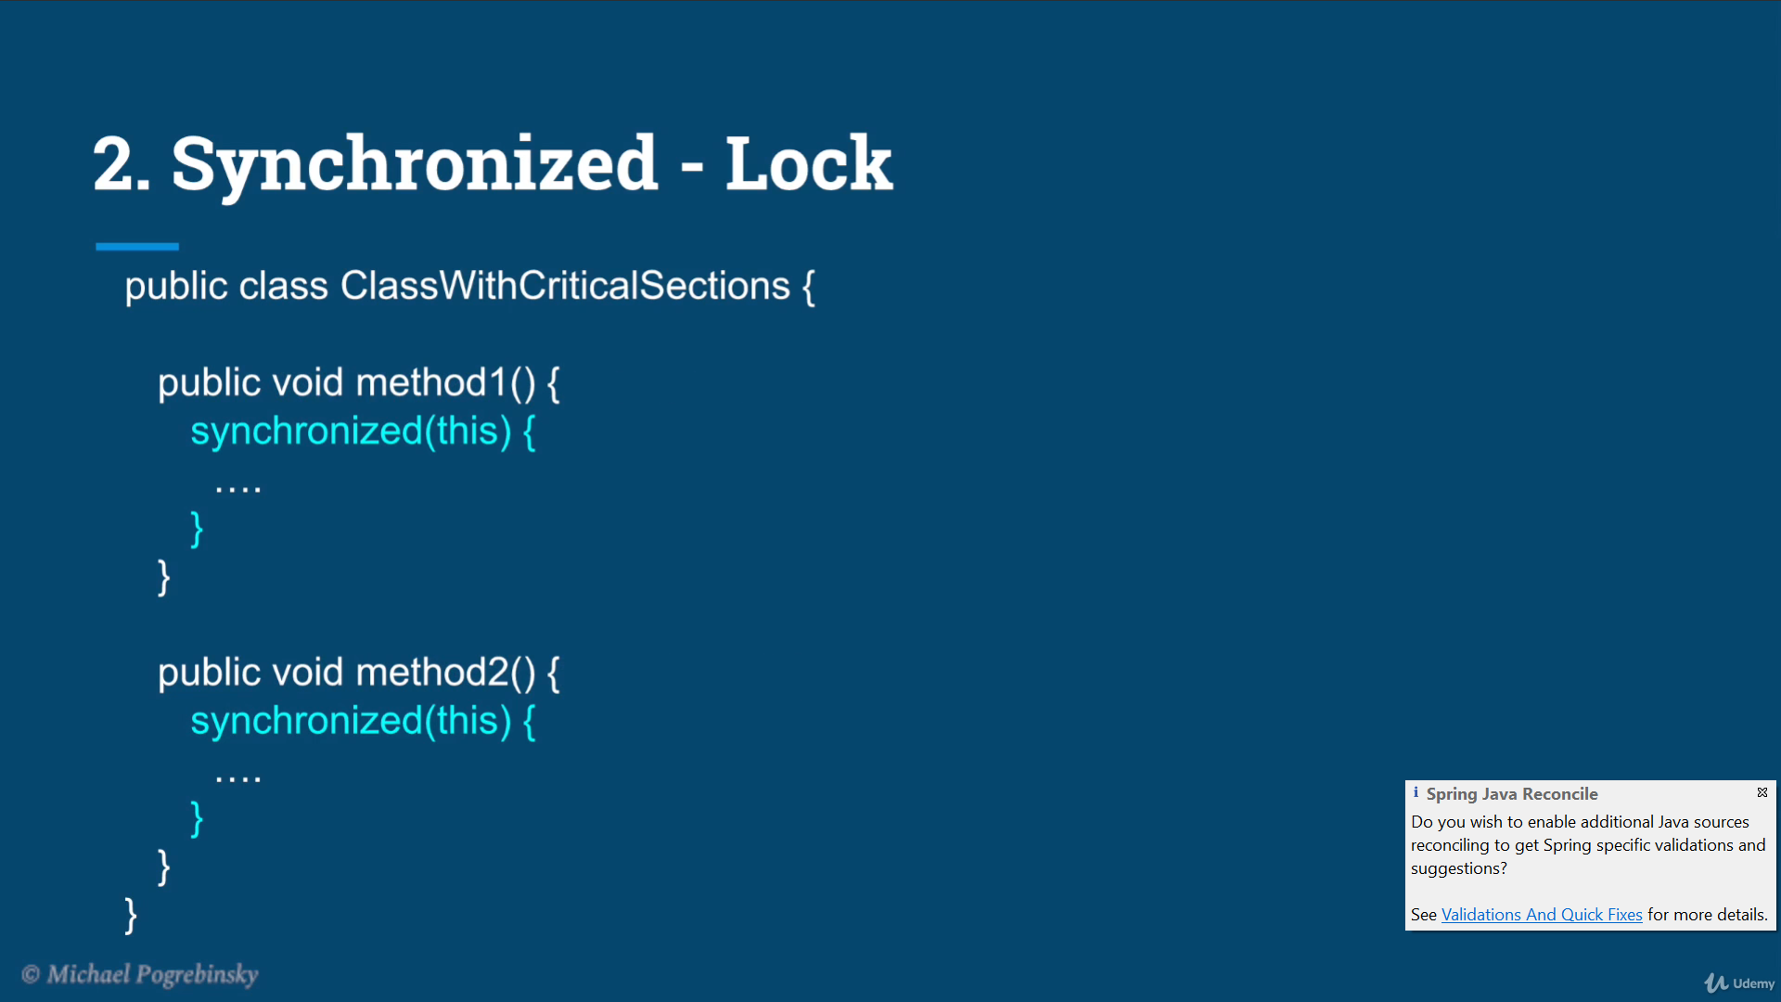

This is so good that when Thread B can access second critical section when thread A is accessing First Critical Section

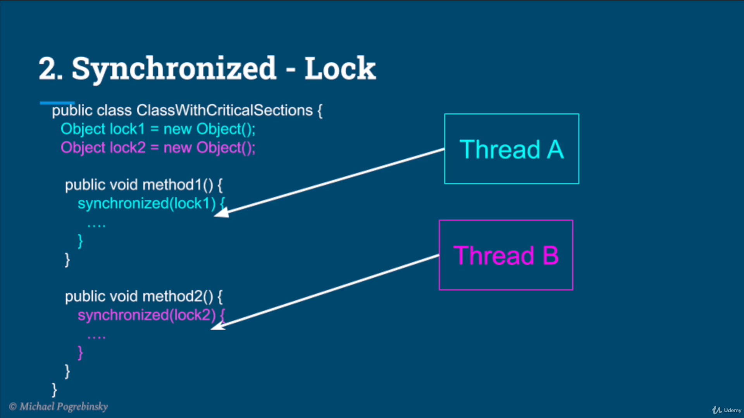

Whereas thread b cant access First Critical Section which is being accessed by Thread A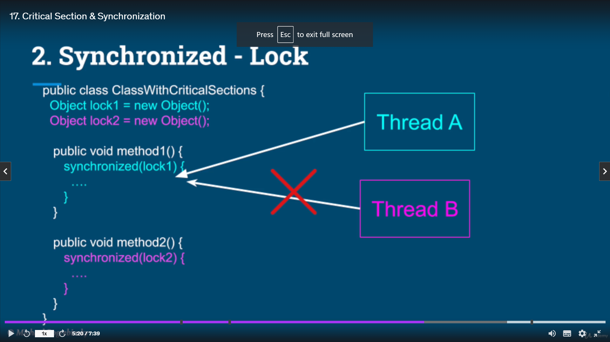

Some times a small piece of code needs to synchronized

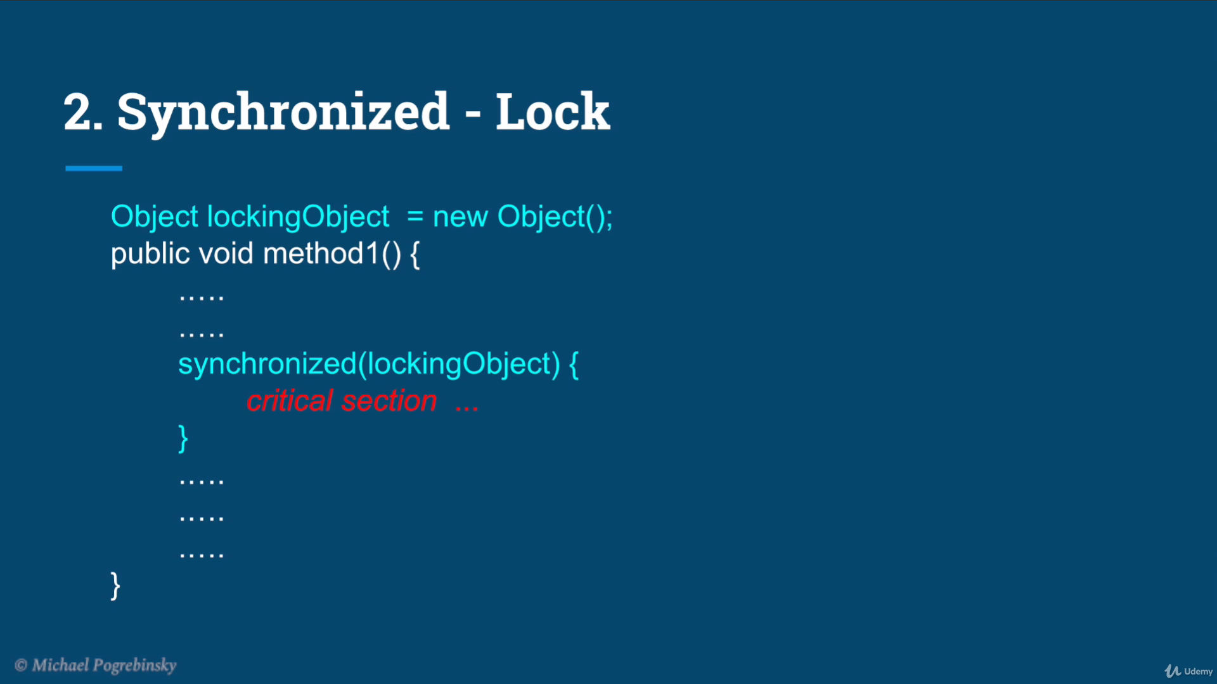

A thread can enter the critical section as long as it has the lock

